Feb. 25, 2019
This year we had the opportunity to do Sanctity of Human Life Sunday at Our Savior Lutheran Church with Debbi Mathews of Care-Net. It is always a great time sharing life and especially with the children of the church.
Feb. we were presented at Mission Sunday with an $800 donation from Our Savior Lutheran Church. Teri Conover, Steve Conover, my husband, Gary Wiffler and me were on hand and weathered the snow to be there. We thank Our Savior Lutheran for their continuing support in our pro-life ministry. Their support helps us pay for Meeker Days, buy Touch of Life baby models, and print the brochures we print each year.
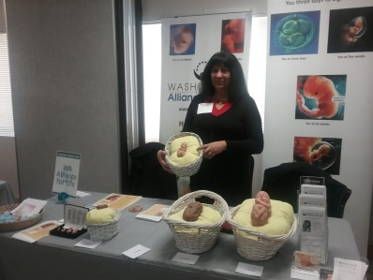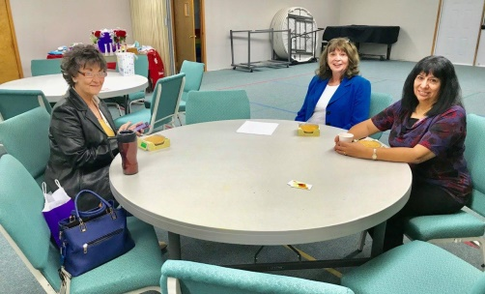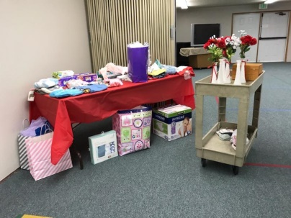

Feb. 23 Washington Alliance for Life had our second annual baby shower at Puyallup Community Baptist Church. We talked a little about the importance of our ministry of which is an umbrella ministry over many pro-life ministries in Pierce County. Showing the Touch of Life baby models does make a difference. Many people have changed their minds on abortion and have chosen life. Many also have found help having their babies in our resource brochures.
We were blessed with a lot of baby clothing of which we will give away at TCC, Meeker Days, WWS Fair and at the Pow Wow in Puyallup. The women heard about our ministry that came and also enjoyed playing games and winning prizes. Teri Conover made a wonderfully delicious cake. One lady took home a dozen red roses.
Besides helping pregnant women and families, we started a few years ago with a brochure that helps seniors. We also do homeless events in Pierce County and will start up again doing the next Pierce County Homeless event that is led by Associated Ministries. Last year there were three homeless pregnant women living on the streets. We pray they found a place for them and their babies.
This year we thank Anya Bostwick that faithfully served volunteering on our board as Vice President. She is now going into the service and we ask for continued prayers for her and her family. Teri Conover will now serve as Vice President of Washington Alliance for Life. The secretary position is now held by Gretchen Eagle. She has volunteered for several years and we are happy she has taken this position.
TCC Health Fair comes up soon and I need one volunteer to help me to do this event. It is March 11. It is 11AM-2 PM. If you are available, please call me. Thank you for helping us serve the Lord. Thank the Lord for his faithfulness to us and our ministry.
In Him for Life,
Glenda Wiffler 253-732-4687

